

Website: https://www.oxfordbathrooms.com.au/

Target Keyword: “Bathroom Renovations”
Sl no | Keywords | Google AU- Avg. monthly searches | Competition
1 | bathroom renovations | 10K – 100K | High
2 | bathroom renovations Sydney | 1K – 10K | Medium

We would like to know more about the current status of this project and work done for past 3 months from client side. Monthly work reports will be fine.

-------------------------------------------------------------------------------------

We did a quick research and prepared an audit report for this:

Home page Meta Title: Bathroom Renovations | Oxford Bathrooms - 39 characters

Description: Bathroom Renovations in Sydney. Oxford Bathroom Designers & Renovators near you are experts in affordable, modern & stunning laundry, ensuite & main bathroom designs. Call 0294847500. - 183 characters

Note: If we are targeting the Home page with the keyword: “Bathroom Renovations” then a separate landing page can be created for the Sydney location, same for any other locations. Every location based landing pages will have keywords optimised content.

So, we need to update home page Meta tags.

Also need to optimise the whole website first.

Home Page Content: Need to add more optimised content on home page, we now have less content on home page.
Lang: en-US
Need to update it to "en-AU"

Heading Tags: Multiple H1 tags (3) available on Home page, need to use only 1 H1 tag with “Bathroom Renovations” or “Bathroom Renovations Sydney”
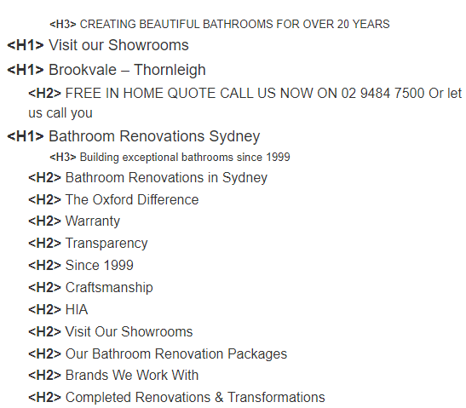

Image Alt Tags: missing! Need to optimise it all (can use “Bathroom Renovations” accordingly)

Redundant Meta Title and Desertions for the pages: Need to update
Page | https://www.oxfordbathrooms.com.au/
Title | Bathroom Renovations | Oxford Bathrooms
Description | Bathroom Renovations in Sydney. Oxford Bathroom Designers & Renovators near you are experts in affordable, modern & stunning laundry, ensuite & main bathroom designs. Call 0294847500.
Page | https://www.oxfordbathrooms.com.au/about-us/
Title | Bathroom Renovation Company Sydney | Oxford Bathrooms
Description | We are Sydney-based bathroom specialists, building beautiful, functional bathrooms with outstanding customer service standards. FREE Quote call 02 9484 7500
Page | https://www.oxfordbathrooms.com.au/thornleigh-showroom/
Title | Learn about Bathroom Renovations from our experienced team
Description | When choosing a bathroom renovations company in Sydney you need to be able to see the work, meet the team and go through the Frequently asked questions.
Page | https://www.oxfordbathrooms.com.au/packages/
Title | Bathroom Renovations Sydney - Bathroom Designers, Renovators
Description | Bathroom Renovations Sydney. Oxford Bathroom Designers & Renovators near you are experts in affordable, modern & stunning laundry, ensuite & main bathroom designs. Call 0294847500.
Page | https://www.oxfordbathrooms.com.au/gallery/
Title | Learn about Bathroom Renovations from our experienced team
Description | When choosing a bathroom renovations company in Sydney you need to be able to see the work, meet the team and go through the Frequently asked questions.

Frequently Asked Questions: Need to add more FAQ on “Bathroom Renovations”

Website Blog post: https://www.oxfordbathrooms.com.au/blog/ No recent blog post. Need to post blogs with keyword optimised content on a regular basis.
Existing Blog posts can be optimised further,

Usability: Please check, this page has usability issues across devices. Also check Google's PageSpeed Insights for Desktop & Mobile

Backlink Strategy: (Most important) we need to create more quality backlinks for branding and higher rankings.

Tasks: Website blog post, offsite blogs, Social bookmarking, business listings, classified, PPT, Quora, etc. as per requirement.

Google Business Profile: We can manage and post (important)
--------------------------------------------------------------------------------------------------------------------
Our main focus would be on:
- Onpage SEO
- Content Optimisation
- Link Building
--------------------------------------------------------------------------------------------------------------------------------

Page Authority: 41
Domain Authority: 23
Spam Score: 1

Also please run a website check on SEM Rush and fix:
