Bikram Biswas  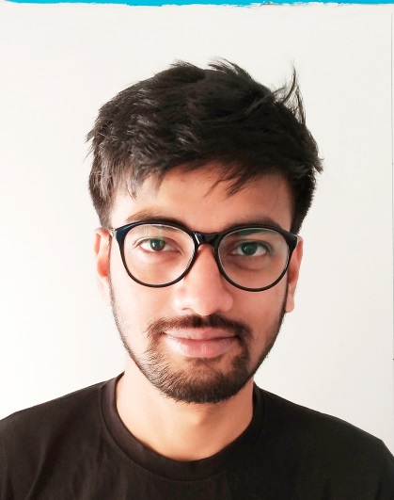  E-MAIL  bikram251994@gmail.com  MOBILE:  +91 9163086973  ADDRESS:  217A, Block -2, Swamiji Park,  Michael Nagar, Kolkata - 700133  PERSONAL DATA  Date of Birth : 25 DEC 1994  Sex : Male  Nationality : Indian  Languages : Bengali, Hindi, English | OBJECTIVE  To work in a challenging environment for a professionally managed and growth-oriented organization where my potentials and experience can be utilized to its maximum capacity.  EDUCATIONAL QUALIFICATION  - WBBSE: 10th Completed with 69% Marks (2010) from Kodaliya Agapur Boys High School.  - WBCHSE: 12th Completed with 61% Marks (Science) (2012) from Birati High School.  - WBSCTE: Completed Electrical Engineering with 7.2  (CGPA) / 69% Marks from Budge Budge Institute of Technology.  - Digital Marketing Course completed from axisnetwork.in  TECHNICAL SKILLS  Operating System: XP, Win 7, Win 8, internet and Emailing  Office Tools: MS office, Basic knowledge in AutoCAD and well experienced in Internet and email, Normal Photo editing.

WORK EXPERIENCE
1st Ex Company Name: Bright Path Technology, (Bangalore)
Joining date 24th April 2018 to 17th May 2019.
Position: Digital marketing Executive.
2nd Ex Company Name: Anzen Exports, (Kolkata)
Joining date 1st Dec 2019 to 19th March 2021,
Position: Digital marketing Executive.
(Worked as Freelancer)
Position: Digital marketing Executive.
Last Company Name: Procentris India Private Limited (Kolkata)
Joining date 14th Dec 2021 to 14th April, 2023.
April to October 2023 I was working for a Startup with my friends.
Last Company Name: Digitex Technologies PVT LTD
Joining date 30th Oct 2023 to 14th May 2024.
Position: Sr. SEO Engineer.
Current Company Name: Webskitters Technologies PVT LTD
Joining date 15th May 2024.
Position: Sr. Digital marketing Executive.
Key Skills:
- SEO On page & off page Optimization, Website Content Optimization, Blog content Optimization.

- Portal Marketing, Business posting, Classified ad posting.

- PPT, PDF, Image & Video Creation and posting in respective portals.

- Using Google Search console, Analytics & Looker Studio for creating Traffic report and Analyzing traffic data.

- Organic SEO Optimization, Social Media Optimization.

- Lead generation in organic way.

- Website Crawl issues report creation and providing the solutions respectively.

- Website Audit and Backlink Audit, Tag Manager.

- Keywords research and analysis, Keywords Rank report preparation.

- Suggesting good keywords for Ads, Google ads forecast, Smart ads, FB Boost post.

- GMB optimization, and Updating.

SEO tools – Semrush, Screaming Frog, GTMetrix, Search Console, SE ranking,
Looker Studio, Analytics, ChatGPT, SEO Small tools, Canva, Ubersuggest, Pingdom Speed tester, Keywords tool planner, SEO Quake, Elementor Pro,
Site Checker, SEO one, PageSpeed Insights, Yoast SEO, Classy Schema Structured Data Viewer, The Hreflang Tags Generator Tool.

HOBBIES AND INTERESTS
Travelling, Movies, Cooking, Playing Football & Cricket, love to read story books.
PERSONAL SKILLS:
- Positive minded, responsible, and result-oriented with an even temperament and has the capacity to quickly learn and implement new methods, systems and procedures.
- Ability to work as a team to achieve organization’s goals.

DECLARATION:

I am confident of my ability to work in a team. I solemnly affirm that the above-furnished particulars are true to the best of my knowledge and belief.

Bikram Biswas

